Word-to-PDF layout test
A controlled document with text, a real table, images, links, fonts, and deliberate page boundaries.
Font controls: Arial 1842 Georgia 1842 Courier New 1842
Element | Expected | Marker
Heading | Georgia | W-101
Table | Four rows | W-202
Link | Clickable URI | W-303
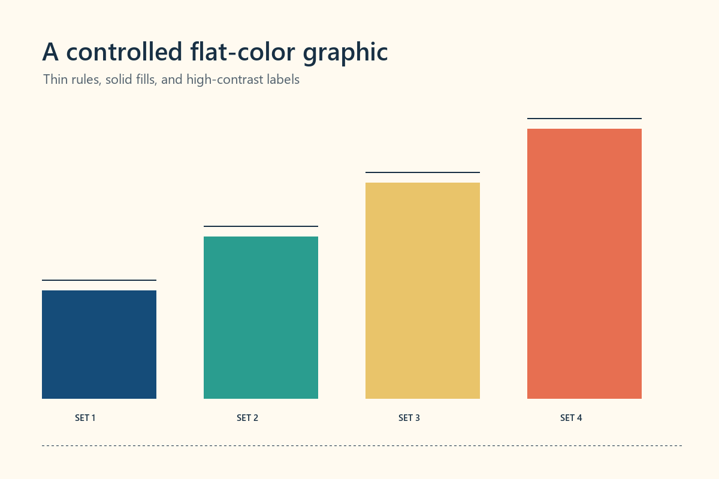
Figure 1. Flat-color source graphic centered below a structured table.
External-link control: https://www.converttwo.com/

Structured body section
Body paragraph 01. Sentinel B-01. This controlled sentence checks line wrapping and page placement in a standard body section.
Body paragraph 02. Sentinel B-02. This controlled sentence checks line wrapping and page placement in a standard body section.
Body paragraph 03. Sentinel B-03. This controlled sentence checks line wrapping and page placement in a standard body section.
Body paragraph 04. Sentinel B-04. This controlled sentence checks line wrapping and page placement in a standard body section.
Body paragraph 05. Sentinel B-05. This controlled sentence checks line wrapping and page placement in a standard body section.
Body paragraph 06. Sentinel B-06. This controlled sentence checks line wrapping and page placement in a standard body section.
Body paragraph 07. Sentinel B-07. This controlled sentence checks line wrapping and page placement in a standard body section.
Body paragraph 08. Sentinel B-08. This controlled sentence checks line wrapping and page placement in a standard body section.
Body paragraph 09. Sentinel B-09. This controlled sentence checks line wrapping and page placement in a standard body section.
Body paragraph 10. Sentinel B-10. This controlled sentence checks line wrapping and page placement in a standard body section.

Image placement page
This page places a wide image at a fixed readable width after an explicit section break.

Final sentinel: WORD-PDF-END-6194

